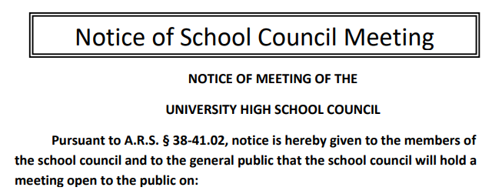

Date: 5/10/2022
Time: 3:30pm
Location: RUHS Library / Online Zoom Session

Agenda:
- Self-Introductions of 2021-2022 School Council Members
- Parliamentary Elections: Chair, Assistant Chair, Secretary, Treasurer
- Approval of the Agenda
- Approval of the April 13th, 2021, Minutes
- Call to the Audience

- Discussion & Action Items
      - Action Item: Approval to move the funds from the previously approved non-gendered Concert Band jackets from the UHS Undesignated Tax Credit account to the RUHS Band account to allow for summer withdrawal of funds without an emergency School Council meeting
- Committee & Misc. Reports
  - Principal’s Report
  - Tax Credit & Budget Committee Report
  - Recruitment & Retention Committee Report
  - Instructional Council Report
  - UHS Foundation & Alumni Association Report
  - Parents Association Report
  - Student Council Report

- Request for Agenda Items for next meeting (please submit action & discussion items in electronic format)
- Reminders:
  - School Council meeting time and place will be posted 24 hours in advance (on UHS Admin. Bulletin Board and in public) on the UHS Site Council website: http://uhssitecouncil.weebly.com/ Attendance and minutes will be submitted to a School Council officer prior to the next meeting.
  - Please observe proper decorum and schedule your time to be able to attend the entire School Council meeting. Each meeting should last 90 minutes and will be adjourned by 5:00 p.m. A quorum, your time, and your participation are valued assets of the UHS School Council.

- Adjournment

Next Meeting: Tuesday, August 16th, 2022
(The third Tuesday of the month to reflect 2nd full week of school for students/parents)

Dated this 8th day of AY, 2022

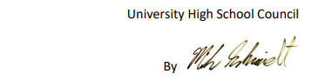

Mike Schmidt, Outgoing University High School Council Facilitator

