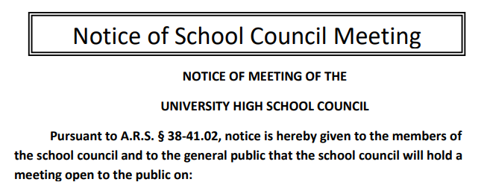

Date: 9/14/2021
Time: 3:30pm
Location: Online Zoom Session

Agenda:
- Self-Introductions of 2021-2022 School Council Members
- Parliamentary Elections: Chair, Assistant Chair, Secretary, Treasurer
- Approval of the Agenda
- Approval of the April 13th, 2021, Minutes
- Call to the Audience

- Discussion & Action Items
      - Action Item: Approval of 2021-2022 Meeting Dates
      - Discussion Item: Online sign-up process for School Council Subcommittees
      - Discussion Item: Required online survey to supply information required for TUSD's School Council Membership forms
      - Action Item: Approval of 2021-2022 Extra-Duty stipends (postponed from the April 2021 meeting)

- Committee & Misc. Reports
  - Principal’s Report
  - Tax Credit & Budget Committee Report
  - Recruitment & Retention Committee Report
  - Instructional Council Report
  - UHS Foundation & Alumni Association Report
  - Parents Association Report
  - Student Council Report

- Request for Agenda Items for next meeting (please submit action & discussion items in electronic format)
- Reminders:
  - School Council meeting time and place will be posted 24 hours in advance (on UHS Admin. Bulletin Board and in public) on the UHS Site Council website: http://uhssitecouncil.weebly.com/ Attendance and minutes will be submitted to a School Council officer prior to the next meeting.
  - Please observe proper decorum and schedule your time to be able to attend the entire School Council meeting. Each meeting should last 90 minutes and will be adjourned by 5:00 p.m. A quorum, your time, and your participation are valued assets of the UHS School Council.

- Adjournment

Next Meeting: Tuesday, October 18th, 2021
(The third Tuesday of the month to accommodate Fall Break)

Dated this 12th day of September, 2021

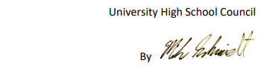

Mike Schmidt, Acting UHS School Council Facilitator

